**The Bachelor Chimp**  
**Input:**Standard Input

**Output:**Standard Output

(Problem 10611 on UVAOnlinejudge.org)

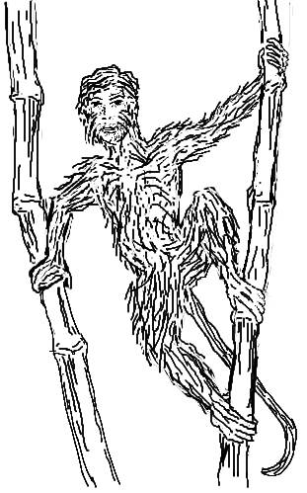Once upon a time, there lived a chimpanzee called *Luchu Bandor (aka Bachelor Chimp)*. Luchu was unhappily dating *Bunty Mona*, a short but cute little lady chimp. Luchu was tall and handsome – he was feeling uncomfortable taking Bunty to public places along with him. People would stare at them all the while. At one point, Luchu could not stand it anymore and he decided to do some justice to his name. He started looking for *a new hope* in the Lady Chimps’ High School. Every day Luchu would climb up a bamboo tree and wait for the morning drill to start. From there he could see each and every lady chimp doing their routine drill. Now, Luchu was looking for the tallest lady chimp that would be shorter than he; he would also like to consider someone a little taller than he. But someone of his same height will never be on his list. Every morning Luchu picks up a line of lady chimps and finds the best two according to his set criterion. His job has been made easy by the fact that the lady chimps in each line are ordered by their height, the shortest one is in the front and the tallest one is at the back. Your task is to help Luchu on one particular day to find two lady chimps: the tallest one shorter than he and the shortest one taller than he.

**Input**

There will be only one set of input for this problem. The first line of input gives you a number **N** **(1≤N≤50000)**, the number of lady chimps on the line. In the next line you would have **N** integers (in the range **1** to **231-1**) giving the heights of the **N** chimps. There would be a single space after every number. You can assume that the chimps are ordered in non-decreasing order of their heights. In the next line you would have an integer **Q (1≤Q≤25000)** giving the number of queries. Then in the next line **Q** queries will follow. Then you would have **Q** numbers giving the height of Luchu! Don’t worry, Luchu is from the land where people can have **3** birthdates; **Q** heights for a chimpanzee will make no difference here. The **Q** numbers are listed on a line and their range from **1 to 231-1**, and as before you would find a single space after every query number. The query numbers are not supposed to come in any particular order.

**Output**

For each query height, print two numbers in one line. The first one would be the height of the tallest lady chimp that is shorter than Luchu, and the next number would be the height of the shortest lady chimp that is taller than he. These two numbers are to be separated by a single space. Whenever it is impossible to find any of these two heights, replace that height with an uppercase **‘X’***.*

**Sample Input                             Output for Sample Input**

|  |  |
| --- | --- |
| **4**  **1 4 5 7**  **4**  **4 6 8 10** | **1 5**  **5 7**  **7 X**  **7 X** |

**Problemsetter: Monirul Hasan, Member of Elite Problemsetters' Panel**

**Luchu’s portrait drawn by: Monirul Hasan**☺